Project Design Phase
Solution Architecture

Date | 29 September 2026
Team ID | 6ab3d326a238dc999eb36ed1
Project Name | AI Weather Wise AP
Maximum Marks | 4 Marks

Solution Architecture – AI WeatherWise API
Solution architecture for the AI WeatherWise API defines how the system components work together to provide real-time weather information and AI-based recommendations.
Frontend / API Client: Sends requests and displays weather information and recommendations.
Express.js Server: Handles API requests, routing, middleware, and responses.
Authentication: JWT and bcrypt provide secure user registration and login.
Weather Service: Retrieves real-time weather data from the weather API.
Gemini AI: Generates simple weather summaries and personalized recommendations.
MongoDB: Stores user details and favorite locations using Mongoose.
Error Handling: Manages invalid requests and service failures.

Overall Flow:
User → Express API → Authentication → Weather API → Gemini AI → MongoDB → Response to User

Example - Solution Architecture Diagram:

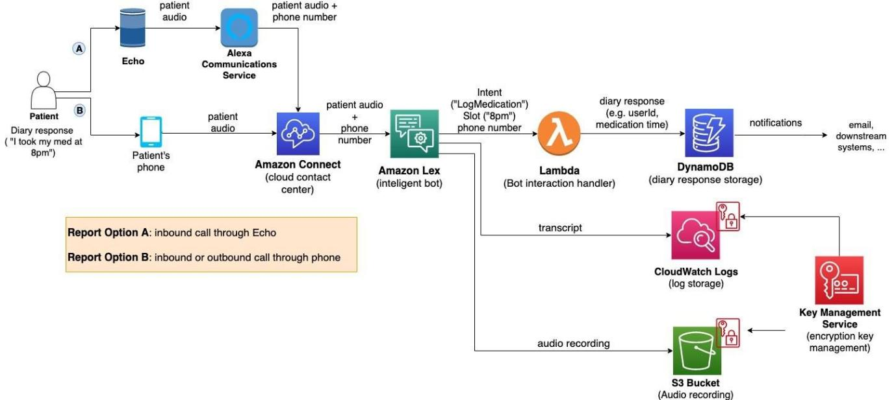
Figure 1: Architecture and data flow of the voice patient diary sample application
Reference: https://aws.amazon.com/blogs/industries/voice-applications-in-clinical-research-powered-by-ai-on-aws-part-1-architecture-and-design-considerations/

